Executive Summary
Fata Plus is an agribusiness and agrotourism startup seeking to connect smallholder farmers in Madagascar with consumers and tourists. By leveraging technology, Fata Plus aims to open new markets and value-added opportunities for farmers while enhancing the agricultural tourism experience.
As an online platform initially, Fata Plus is working to establish regional farmer training hubs, agritourism lodges, and a main campus over the next 3-5 years. These locations will serve as experiential learning centers and sales channels, supporting the transition to sustainable farming practices and direct sales. Easy-to-use digital tools will integrate the farmer and tourist experience.
Fata Plus will facilitate direct website sales, retail partnerships, and business-to-business sales through its sales team. Strategies for boosting revenue include increased digital marketing, new retail partners, growing the sales team, and promotions to encourage repeat purchases.
To reach target customers, Fata Plus will employ social media engagement, search engine optimization, online advertising, content marketing, email newsletters, PR opportunities, and analytics to optimize efforts.
Fata Plus's competitive edge comes from its promotion of sustainable agriculture, assistance with agritech financing, blend of tech and agricultural expertise, research partnerships, user-friendly farmer tools, and immersive agritourism. This positions the startup strongly in the changing agribusiness and tourism landscape.
By addressing key challenges like market access, inability to process goods, and lack of distribution for smallholder farmers, Fata Plus can tap into Madagascar's underutilized agricultural potential. It will target local and international consumers and tourists to generate revenue while improving farmer livelihoods.
At its core is an innovative digital platform connecting farmers, consumers, investors and institutions. Additional agent support will ensure all farmers can access the platform. This comprehensive solution empowers farmers, enriches visitor experiences, and fosters environmental and economic sustainability.

Opportunity

Problem & Solution

Problem Worth Solving
Lack of access to markets for smallholder farmers
In Madagascar, 80% of the population are smallholder farmers who struggle to access markets to sell their produce. Often, they have to accept low prices from middlemen, getting only a fraction of the true value of their hard work.
Without access to wider markets, smallholder farmers remain trapped in subsistence farming, unable to invest in inputs, equipment and skills that could significantly increase their productivity and income. They lack bargaining power, market information, logistics and relationships that commercial farmers rely on.
Inability to add value through processing
Smallholder farmers typically sell raw commodities, missing out on the opportunity to increase income through value-added processing. They lack the equipment, skills, relationships and market access needed to process and sell finished goods.
For example, selling raw cacao beans instead of chocolate bars means farmers don't benefit from the significant markup gained in subsequent steps of the value chain.
Lack of efficient distribution
Smallholder farmers struggle to get their produce from rural farms to urban markets efficiently. Long distances, poor roads, lack of transport, lack of storage and high costs make it difficult to distribute perishable goods before they spoil.
This results in high levels of food waste and lost income. Efficient distribution is key to connecting rural producers with urban consumers.

Our Solution
At Fata Plus, our agribusiness and agritourism solution is designed to address the key challenges faced by farmers and visitors in Madagascar. We provide an innovative platform that connects local farmers to consumers online, giving them a unique opportunity to increase their income.
Our solution is based on three key pillars:
- Facilitating access to sustainable agriculture - We focus on promoting environmentally friendly farming practices, supporting farmers in implementing solutions like organic farming, permaculture, and agroforestry.
- Enabling access to agritech funding - We assist farmers in accessing and securing financing from institutions providing grants and investments in the agritech space. This includes guiding them through the often complex application processes.
- Bridging the gap between agriculture and tourism - Our platform allows visitors to discover and directly purchase agricultural products and experiences from local farmers. This provides a new revenue stream for farmers while enhancing the tourism experience.
At the core of our solution is an innovative digital platform that connects the stakeholders in this ecosystem. Farmers can easily showcase and sell their products, manage online orders, and apply for financing. Visitors can discover unique agricultural experiences, purchase fresh local goods, and learn about sustainable practices. Investors and institutions can efficiently evaluate and manage grant applications.
Additionally, we provide specialized agents who can personally assist farmers, particularly those less familiar with technology, in accessing and utilizing our online platform. These agents ensure that all farmers can benefit fully from our services.
In summary, our well-rounded solution is tailored to the needs of Malagasy agriculture and tourism. By bridging these sectors we empower farmers, enrich the visitor experience, and promote environmentally and economically sustainable practices.

Target Market
Madagascar possède un énorme potentiel pour le développement des marchés agricoles, avec plus de 80% de la population active travaillant dans ce secteur. Cependant, de nombreux défis persistent, tels que l'accès limité aux marchés, le manque d'infrastructures, et des techniques agricoles obsolètes.
Fata Plus vise à exploiter ce potentiel inexploité en se concentrant sur les segments de marché suivants :
- Consommateurs locaux - La demande pour des produits agricoles de qualité augmente avec la croissance de la classe moyenne malgache. Fata Plus peut répondre à ce besoin sur le marché intérieur.
- Consommateurs internationaux - L'exportation de produits agricoles représente une opportunité importante pour les petits exploitants. Fata Plus facilitera l'accès aux marchés internationaux.
- Touristes - Le tourisme est en plein essor à Madagascar. Fata Plus proposera des activités agrotouristiques pour attirer cette clientèle.
En ciblant stratégiquement ces segments de marché, Fata Plus pourra générer des revenus substantiels tout en améliorant les moyens de subsistance des petits exploitants agricoles malgaches.

Competition

Current Alternatives

Our Advantages
Fata Plus possède plusieurs avantages concurrentiels sur le marché de l'agritech et de l'agrotourisme.
- Nous promouvons une agriculture durable et respectueuse de l'environnement, en soutenant les pratiques agroécologiques.
- Nous aidons les agriculteurs à accéder à des financements pour la transition agroécologique proposés par des institutions publiques ou privées.
- Notre équipe combine une expertise technologique et une connaissance fine du monde agricole pour proposer des solutions adaptées.
- Nous travaillons en partenariat avec des centres de recherche afin de rester à la pointe des innovations dans le domaine de l'agriculture numérique.
- Nos solutions digitales sont simples à utiliser et spécifiquement conçues pour les besoins des agriculteurs.
- Nos séjours à la ferme permettent de créer un lien direct entre agriculteurs et consommateurs autour d'une agriculture plus durable.
Ces atouts nous permettent de nous démarquer sur un marché en pleine mutation et de répondre aux attentes des agriculteurs comme des consommateurs en matière d'agriculture responsable.

Execution

Marketing & Sales

Marketing Plan
Pour toucher notre public cible, nous utiliserons plusieurs canaux marketing:
- Réseaux sociaux - Nous publierons du contenu engageant et informatif sur notre page Facebook pour générer de l'intérêt et attirer de nouveaux clients.
- Site web - Notre site web présentera nos services et permettra aux clients de nous contacter facilement.
- Publicité en ligne - Nous utiliserons Google Ads et les réseaux sociaux pour cibler des annonces vers notre public cible.
- Marketing de contenu - Nous créerons du contenu de blog et des infolettres pour fournir de la valeur à notre public.
- Relations publiques - Nous chercherons des opportunités dans les médias locaux pour promouvoir notre entreprise.
Pour mesurer l'efficacité de nos efforts marketing, nous utiliserons des outils d'analyse tels que Google Analytics pour suivre le trafic de notre site web, les taux de conversion et d'autres mesures clés de performance.
Notre budget marketing initial sera axé sur la création de notre présence en ligne par le biais de notre site web, de publicités payantes et de contenu organique sur les réseaux sociaux. À mesure que nous nous développerons, nous investirons davantage dans des campagnes publicitaires ciblées et des relations publiques pour accroître notre notoriété.

Sales Plan
Our sales plan outlines our strategies for generating revenue through sales of our agribusiness and agrotourism solutions and services. Our primary sales channels are:
- Direct sales through our website - Customers can purchase our products and services directly on our website through our online store. We offer a convenient and secure online checkout and accept all major credit cards as well as PayPal.
- Retail partners - We have partnerships with select retail stores that sell our products on consignment. This expands our reach to customers who prefer to shop in-store.
- Sales team - Our sales team focuses on developing relationships with large agribusinesses, farmers' cooperatives, and agricultural associations to sell them our products and services in bulk.
We plan to expand our sales by:
- Increasing digital marketing to drive more website traffic and online sales.
- Establishing sales partnerships with additional retailers to increase our in-store presence.
- Growing our sales team to increase direct business-to-business sales.
- Offering promotions and discounts to encourage repeat purchases.
We closely track sales data and metrics to identify opportunities for improvement. We will refine our sales strategies over time to maximize revenue while providing an excellent customer experience.

Operations

Locations & Facilities
As Fata Plus is currently limited to an online presence, we do not currently have any physical office locations or facilities. However, as part of our long-term growth strategy, we plan to establish physical locations to support our training programs for farmers and agrotourism activities.
We envision establishing three types of physical locations over the next 3-5 years:
- Regional training centers - These locations will serve as hubs for providing in-person training to farmers in major agricultural regions. They will include classrooms, demo farms, and dormitories.
- Agrotourism lodges - Situated near major agricultural attractions, these small lodges will provide accommodation for agrotourism tourists.
- Main campus - Our main campus will house our headquarters, additional training facilities, and serve as a showcase for innovative agricultural practices.
As we expand, we plan to initially establish 1-2 regional training centers and 1-2 agrotourism lodges in key locations. Our main headquarters campus will likely be located in a major city with strong transportation links.
In selecting locations, key factors will include proximity to our target farmer and tourist demographics, affordable real estate, supportive local partnerships, and accessibility. We will aim to lease existing facilities where possible, building out custom features as needed for our programs.
Our facilities will be designed to provide an engaging, informative, and comfortable environment for our clients. Experiential learning and sustainable agriculture will be emphasized throughout. We will maintain strong IT infrastructure to enable seamless integration with our online platforms.

Technology
-

Equipment & Tools

Milestones & Metrics

Milestones Table
Milestone | Due Date

Key Metrics

Company

Overview

Team

Management Team

Advisors

Financial Plan

Forecast

Key Assumptions

Revenue by Month
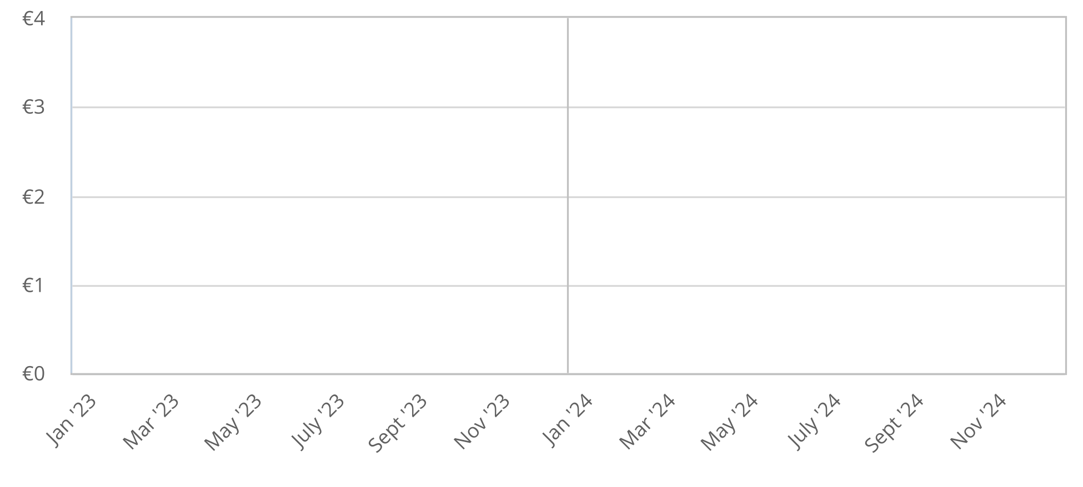

Expenses by Month


Net Profit (or Loss) by Year
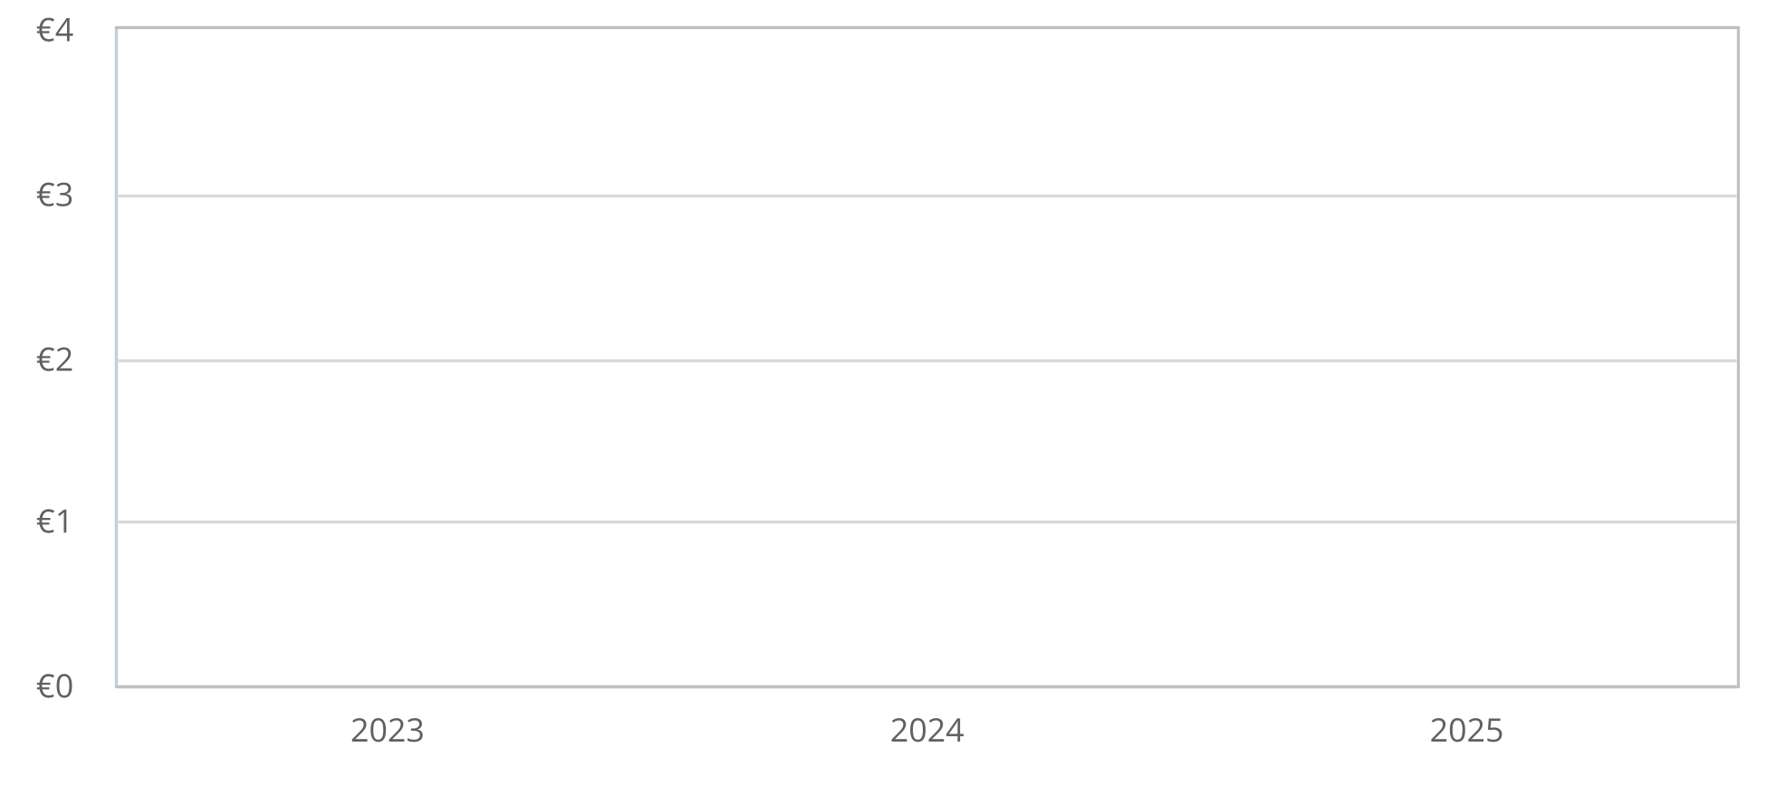

Financing

Use of Funds

Sources of Funds

Statements

Projected Profit and Loss
 | 2023 | 2024 | 2025
Revenue
Direct Costs
Gross Margin
Gross Margin %
Operating Expenses
Total Operating Expenses
Operating Income
Interest Incurred
Depreciation and Amortization
Gain or Loss from Sale of Assets
Income Taxes
Total Expenses
Net Profit
Net Profit / Sales

Projected Balance Sheet
 | 2023 | 2024 | 2025
Cash
Accounts Receivable
Inventory
Other Current Assets
Total Current Assets
Long-Term Assets
Accumulated Depreciation
Total Long-Term Assets
Total Assets
Accounts Payable
Income Taxes Payable
Sales Taxes Payable
Short-Term Debt
Prepaid Revenue
Total Current Liabilities
Long-Term Debt
Long-Term Liabilities
Total Liabilities
Paid-In Capital
Retained Earnings
Earnings
Total Owner's Equity
Total Liabilities & Equity

Projected Cash Flow Statement
 | 2023 | 2024 | 2025
Net Cash Flow from Operations
Net Profit
Depreciation & Amortization
Change in Accounts Receivable
Change in Inventory
Change in Accounts Payable
Change in Income Tax Payable
Change in Sales Tax Payable
Change in Prepaid Revenue
Net Cash Flow from Operations
Investing & Financing
Assets Purchased or Sold
Net Cash from Investing
Investments Received
Dividends & Distributions
Change in Short-Term Debt
Change in Long-Term Debt
Net Cash from Financing
Cash at Beginning of Period
Net Change in Cash
Cash at End of Period

Appendix

Profit and Loss Statement (With Monthly Detail)
2023 | Jan '23 | Feb '23 | Mar '23 | Apr '23 | May '23 | June '23 | July '23 | Aug '23 | Sept '23 | Oct '23 | Nov '23 | Dec '23
Total Revenue
Total Direct Costs
Gross Margin
Gross Margin %
Operating Expenses
Operating Income
Interest Incurred
Depreciation and Amortization
Gain or Loss from Sale of Assets
Income Taxes
Total Expenses
Net Profit
Net Profit / Sales

2024 | Jan '24 | Feb '24 | Mar '24 | Apr '24 | May '24 | June '24 | July '24 | Aug '24 | Sept '24 | Oct '24 | Nov '24 | Dec '24
Total Revenue
Total Direct Costs
Gross Margin
Gross Margin %
Operating Expenses
Operating Income
Interest Incurred
Depreciation and Amortization
Gain or Loss from Sale of Assets
Income Taxes
Total Expenses
Net Profit
Net Profit / Sales

 | 2023 | 2024 | 2025
Total Revenue
Total Direct Costs
Gross Margin
Gross Margin %
Operating Expenses
Operating Income
Interest Incurred
Depreciation and Amortization
Gain or Loss from Sale of Assets
Income Taxes
Total Expenses
Net Profit
Net Profit / Sales

Balance Sheet (With Monthly Detail)
2023 | Jan '23 | Feb '23 | Mar '23 | Apr '23 | May '23 | June '23 | July '23 | Aug '23 | Sept '23 | Oct '23 | Nov '23 | Dec '23
Cash
Accounts Receivable
Inventory
Other Current Assets
Total Current Assets
Long-Term Assets
Accumulated Depreciation
Total Long-Term Assets
Total Assets
Accounts Payable
Income Taxes Payable
Sales Taxes Payable
Short-Term Debt
Prepaid Revenue
Total Current Liabilities
Long-Term Debt
Long-Term Liabilities
Total Liabilities
Paid-In Capital
Retained Earnings
Earnings
Total Owner's Equity
Total Liabilities & Equity

2024 | Jan '24 | Feb '24 | Mar '24 | Apr '24 | May '24 | June '24 | July '24 | Aug '24 | Sept '24 | Oct '24 | Nov '24 | Dec '24
Cash
Accounts Receivable
Inventory
Other Current Assets
Total Current Assets
Long-Term Assets
Accumulated Depreciation
Total Long-Term Assets
Total Assets
Accounts Payable
Income Taxes Payable
Sales Taxes Payable
Short-Term Debt
Prepaid Revenue
Total Current Liabilities
Long-Term Debt
Long-Term Liabilities
Total Liabilities
Paid-In Capital
Retained Earnings
Earnings
Total Owner's Equity
Total Liabilities & Equity

 | 2023 | 2024 | 2025
Cash
Accounts Receivable
Inventory
Other Current Assets
Total Current Assets
Long-Term Assets
Accumulated Depreciation
Total Long-Term Assets
Total Assets
Accounts Payable
Income Taxes Payable
Sales Taxes Payable
Short-Term Debt
Prepaid Revenue
Total Current Liabilities
Long-Term Debt
Long-Term Liabilities
Total Liabilities
Paid-In Capital
Retained Earnings
Earnings
Total Owner's Equity
Total Liabilities & Equity

Cash Flow Statement (With Monthly Detail)
2023 | Jan '23 | Feb '23 | Mar '23 | Apr '23 | May '23 | June '23 | July '23 | Aug '23 | Sept '23 | Oct '23 | Nov '23 | Dec '23
Net Cash Flow from Operations
Net Profit
Depreciation & Amortization
Change in Accounts Receivable
Change in Inventory
Change in Accounts Payable
Change in Income Tax Payable
Change in Sales Tax Payable
Change in Prepaid Revenue
Net Cash Flow from Operations
Investing & Financing
Assets Purchased or Sold
Net Cash from Investing
Investments Received
Dividends & Distributions
Change in Short-Term Debt
Change in Long-Term Debt
Net Cash from Financing
Cash at Beginning of Period
Net Change in Cash
Cash at End of Period

2024 | Jan '24 | Feb '24 | Mar '24 | Apr '24 | May '24 | June '24 | July '24 | Aug '24 | Sept '24 | Oct '24 | Nov '24 | Dec '24
Net Cash Flow from Operations
Net Profit
Depreciation & Amortization
Change in Accounts Receivable
Change in Inventory
Change in Accounts Payable
Change in Income Tax Payable
Change in Sales Tax Payable
Change in Prepaid Revenue
Net Cash Flow from Operations
Investing & Financing
Assets Purchased or Sold
Net Cash from Investing
Investments Received
Dividends & Distributions
Change in Short-Term Debt
Change in Long-Term Debt
Net Cash from Financing
Cash at Beginning of Period
Net Change in Cash
Cash at End of Period

 | 2023 | 2024 | 2025
Net Cash Flow from Operations
Net Profit
Depreciation & Amortization
Change in Accounts Receivable
Change in Inventory
Change in Accounts Payable
Change in Income Tax Payable
Change in Sales Tax Payable
Change in Prepaid Revenue
Net Cash Flow from Operations
Investing & Financing
Assets Purchased or Sold
Net Cash from Investing
Investments Received
Dividends & Distributions
Change in Short-Term Debt
Change in Long-Term Debt
Net Cash from Financing
Cash at Beginning of Period
Net Change in Cash
Cash at End of Period

